 

**Department of Computer Science**

**National University of Computer & Emerging Sciences**

DevOps-Assignment 03



**Implementation of Continuous Integration Pipelines for a Full-Stack Application Using GitHub Actions**

**Group Members**

* **Saad Rehman (21F-9640)**
* **Ali Shaikh (21F-9631)**
* **Huzaifa Saqib (21F-9644)**

**Course Instructor**

* **Jawad Khalid Cheema**

**GitHub Repository:**

[Click here](https://github.com/saadrehman171000/DevOps-Pipeline-Automation)

**Table of Contents**

**1. Introduction** 3

**2. Assignment Breakdown** 3

**3. CI Pipeline Implementation** 3

**4. Demonstration of CI Jobs** 7

**4.1 GitHub Actions History:** 7

**4.2 Pull Requests:** 9

**4.3 Issues Tracking:** 11

**5. Monitoring with Slack Incoming Webhook** 12

**5.1 Creating the Slack Incoming Webhook** 12

**5.2 Updating GitHub Secrets** 13

**5.3 Configuring GitHub Actions for Notifications** 14

**5.4 Testing the Notification System** 14

**6. Conclusion** 15

# **1. Introduction**

This report outlines the process and steps taken to complete the Continuous Integration (CI) assignment for my Final Year Project (FYP). The primary objective was to set up CI pipelines using GitHub Actions for a full-stack application, ensuring the automation of builds, tests, and deployments.

# **2. Assignment Breakdown**

1. **Project Setup**
   * Created a new repository on GitHub and transferred the existing FYP codebase into this repository.
   * Ensured that the repository follows the best practices for project structure and organization.
2. **Task Breakdown and Issue Creation**
   * Analyzed the project requirements and divided them into smaller tasks.
   * Created GitHub issues for each task to track progress and assigned them to team members as necessary.
3. **Branching and Git Workflow**
   * Followed proper Git workflows by creating feature branches for each task.
   * Merged changes to the main branch using pull requests (PRs) to maintain a clean project history.

# **3. CI Pipeline Implementation**

1. **Setting Up CI Pipeline with GitHub Actions**
   * Created a .github/workflows/ci.yml file in the repository for GitHub Actions.

**CI Configuration:**

name: CI Pipeline

on:

  push:

    branches:

      - main  # Trigger on pushes to the main branch

  pull_request:

    branches:

      - main  # Trigger on pull requests to the main branch

jobs:

  # 1. Build Docker Images for Components

  build:

    runs-on: ubuntu-latest

    steps:

      - name: Checkout code

        uses: actions/checkout@v3  # Check out the code in the repository

      - name: Set up Docker Buildx

        uses: docker/setup-buildx-action@v2  # Set up Docker Buildx for building multi-platform images

      - name: Cache Docker Layers

        uses: actions/cache@v3  # Cache Docker layers to speed up builds

        with:

          path: /tmp/.buildx-cache  # Specify cache path

          key: ${{ runner.os }}-docker-${{ github.sha }}  # Cache key

          restore-keys: |

            ${{ runner.os }}-docker-

      - name: Login to DockerHub

        run: echo "${{ secrets.DOCKER_PASSWORD }}" | docker login -u "${{ secrets.DOCKER_USERNAME }}" --password-stdin  # Log in to DockerHub

      - name: Build Frontend Container

        run: docker build -t saadrehman17100/frontend:latest -f Dockerfile .  # Build the frontend Docker image

      - name: Build Backend Container (if applicable)

        run: docker build -t saadrehman17100/backend:latest -f Dockerfile .  # Build the backend Docker image

      - name: Push Frontend Image to DockerHub

        run: docker push saadrehman17100/frontend:latest  # Push the frontend image to DockerHub

      - name: Push Backend Image to DockerHub

        run: docker push saadrehman17100/backend:latest  # Push the backend image to DockerHub

  # 2. Run Unit Tests

  unit-tests:

    runs-on: ubuntu-latest

    needs: build  # Ensure this job runs after the build job

    steps:

      - name: Checkout code

        uses: actions/checkout@v3  # Check out the code

      - name: Install Dependencies

        run: npm install  # Install project dependencies

      - name: Run Unit Tests

        run: npm test -- --json --outputFile=test-results.json  # Run tests and output results to a JSON file

      - name: Upload Test Results

        uses: actions/upload-artifact@v3  # Upload test results as artifacts

        with:

          name: test-results  # Artifact name

          path: test-results.json  # Path to the test results file

  # 3. Linter Job (ESLint)

  lint:

    runs-on: ubuntu-latest

    steps:

      - name: Checkout code

        uses: actions/checkout@v3  # Check out the code

      - name: Install ESLint

        run: npm install eslint --save-dev  # Install ESLint as a development dependency

      - name: Run ESLint

        run: npx eslint ./ --ext .ts,.tsx --fix  # Run ESLint to check code quality and automatically fix issues

  # 4. SAST Job (Semgrep)

  sast:

    runs-on: ubuntu-latest

    steps:

      - name: Checkout code

        uses: actions/checkout@v3

      - name: Run Semgrep for Security Analysis

        run: |

          docker run --rm --volume "$PWD:/src" returntocorp/semgrep semgrep --config=p/ci .

  # 5. Slack Notification Job

  notify:

    runs-on: ubuntu-latest

    needs: [build, lint, unit-tests, sast]

    steps:

      - name: Notify Slack

        run: |

          curl -X POST -H 'Content-type: application/json' --data '{

            "text": "CI Pipeline Notification: All jobs have completed successfully!"

          }' ${{ secrets.SLACK_WEBHOOK_URL }}  # Use the secret

**2. Commands for Testing Each Task**

* **Task 1: Build Docker Containers**
  + Command to trigger the pipeline:
    - git push origin main

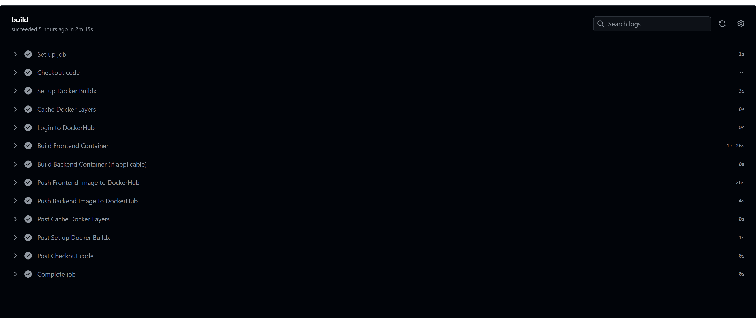

* **Task 2: Run Unit Tests**
  + Command to trigger the pipeline:
    - npm test

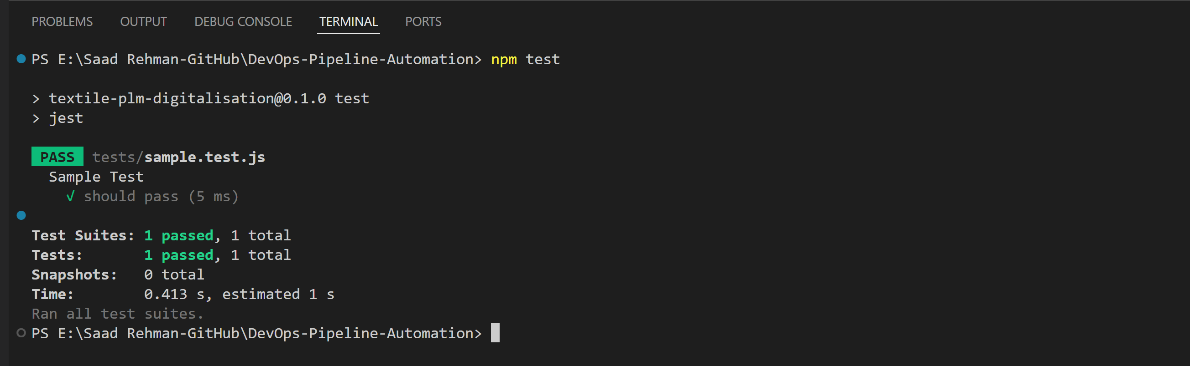

* **Task 3: Run Linter and SAST Jobs**
  + Command to run linter:
    - npx eslint . –fix

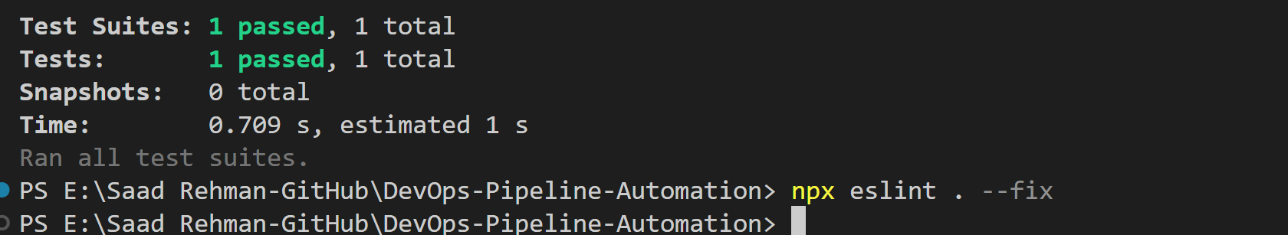

* + Command to run SAST using Semgrep
    - docker run --rm --volume "$PWD:/src" returntocorp/semgrep semgrep --config=p/ci .

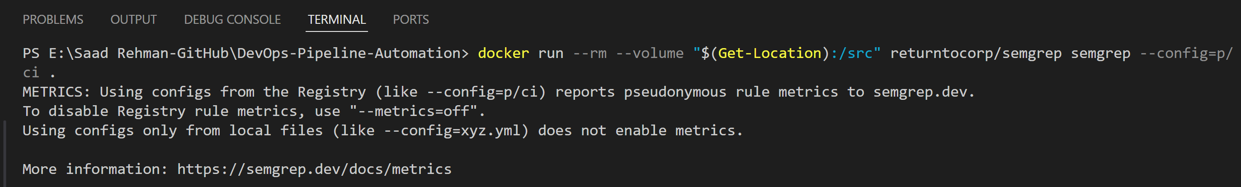

* **Task 4: Push Containers to DockerHub**
  + Command to log in to DockerHub and push images:
    - docker push saadrehman17100/frontend:latest

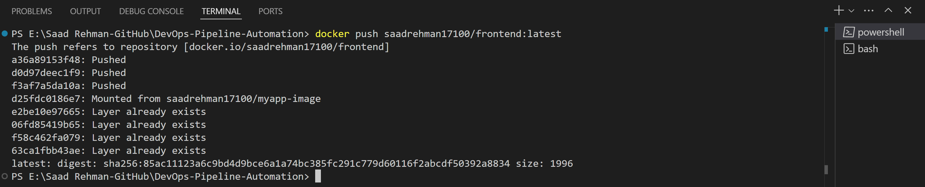

# **4. Demonstration of CI Jobs**

## **4.1 GitHub Actions History:**

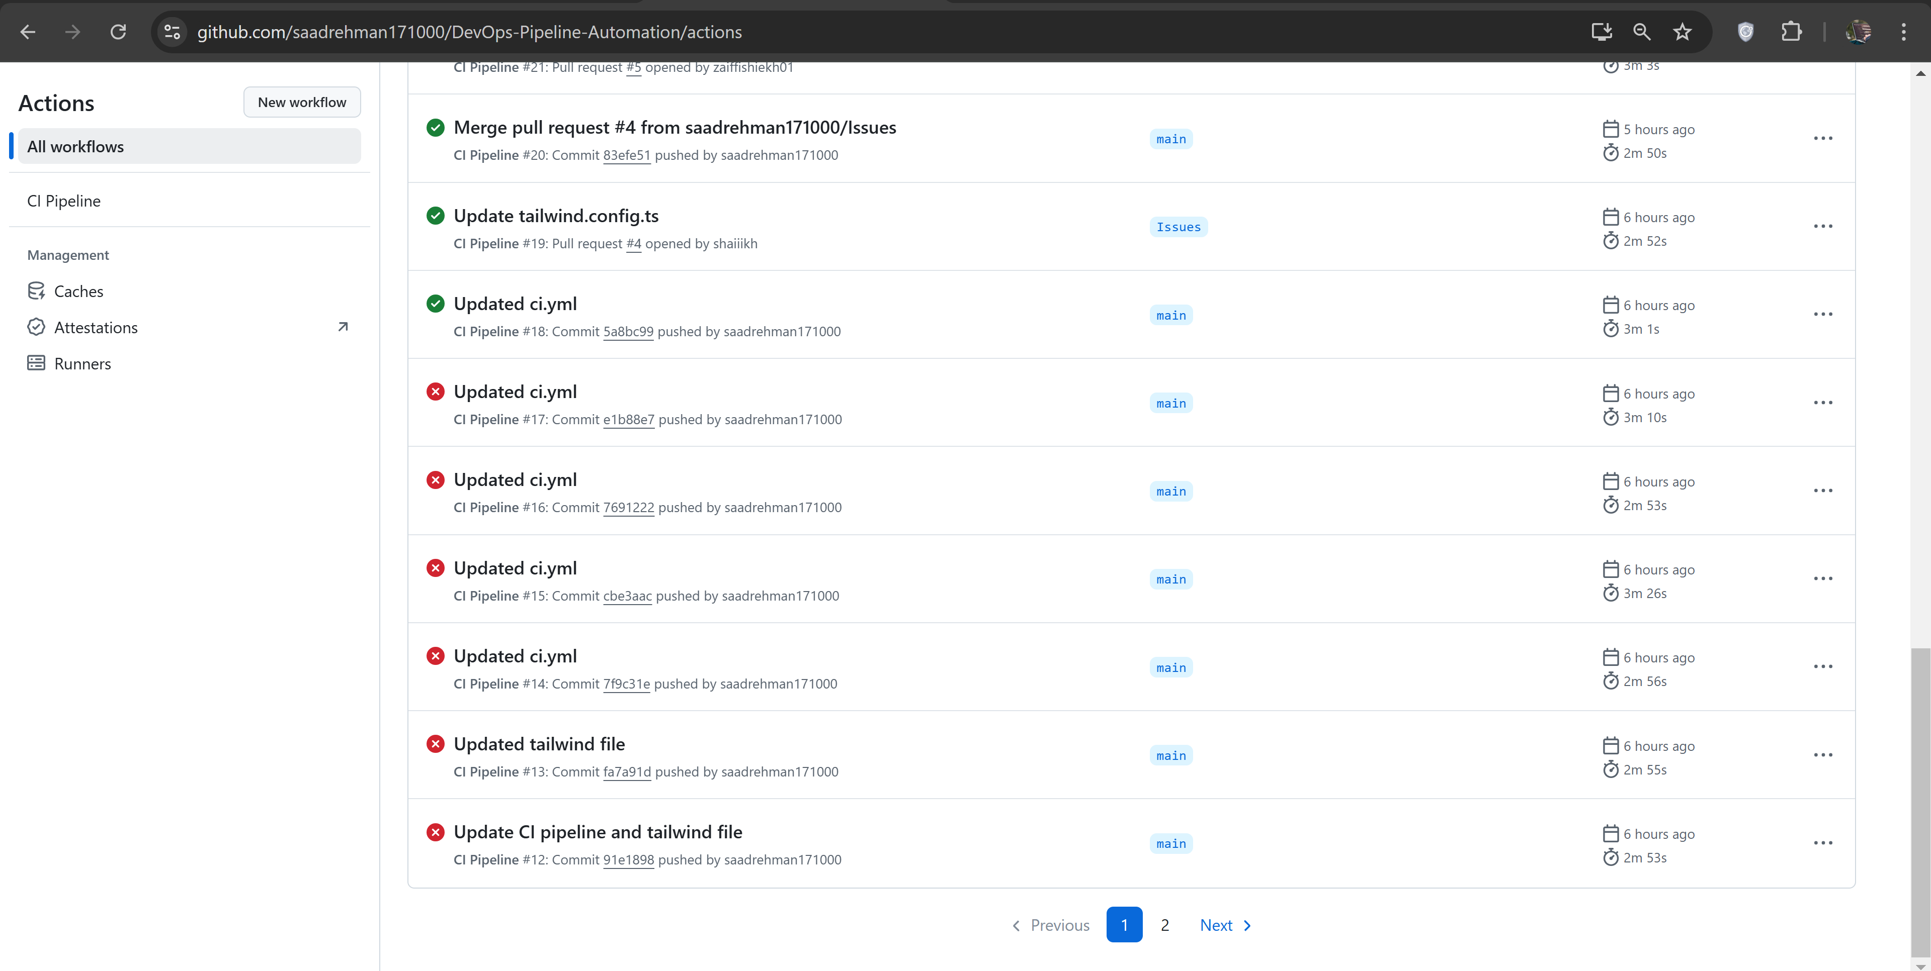

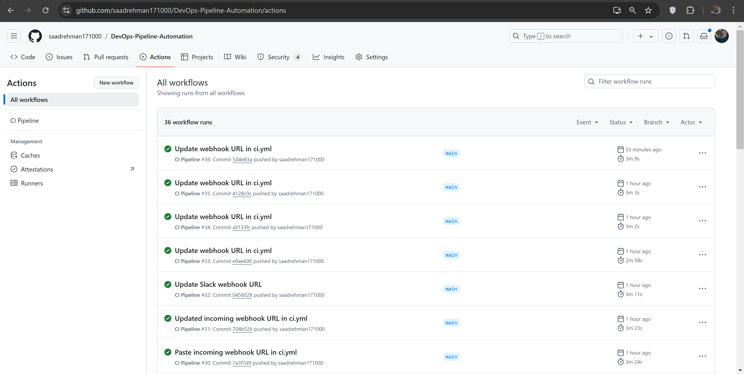

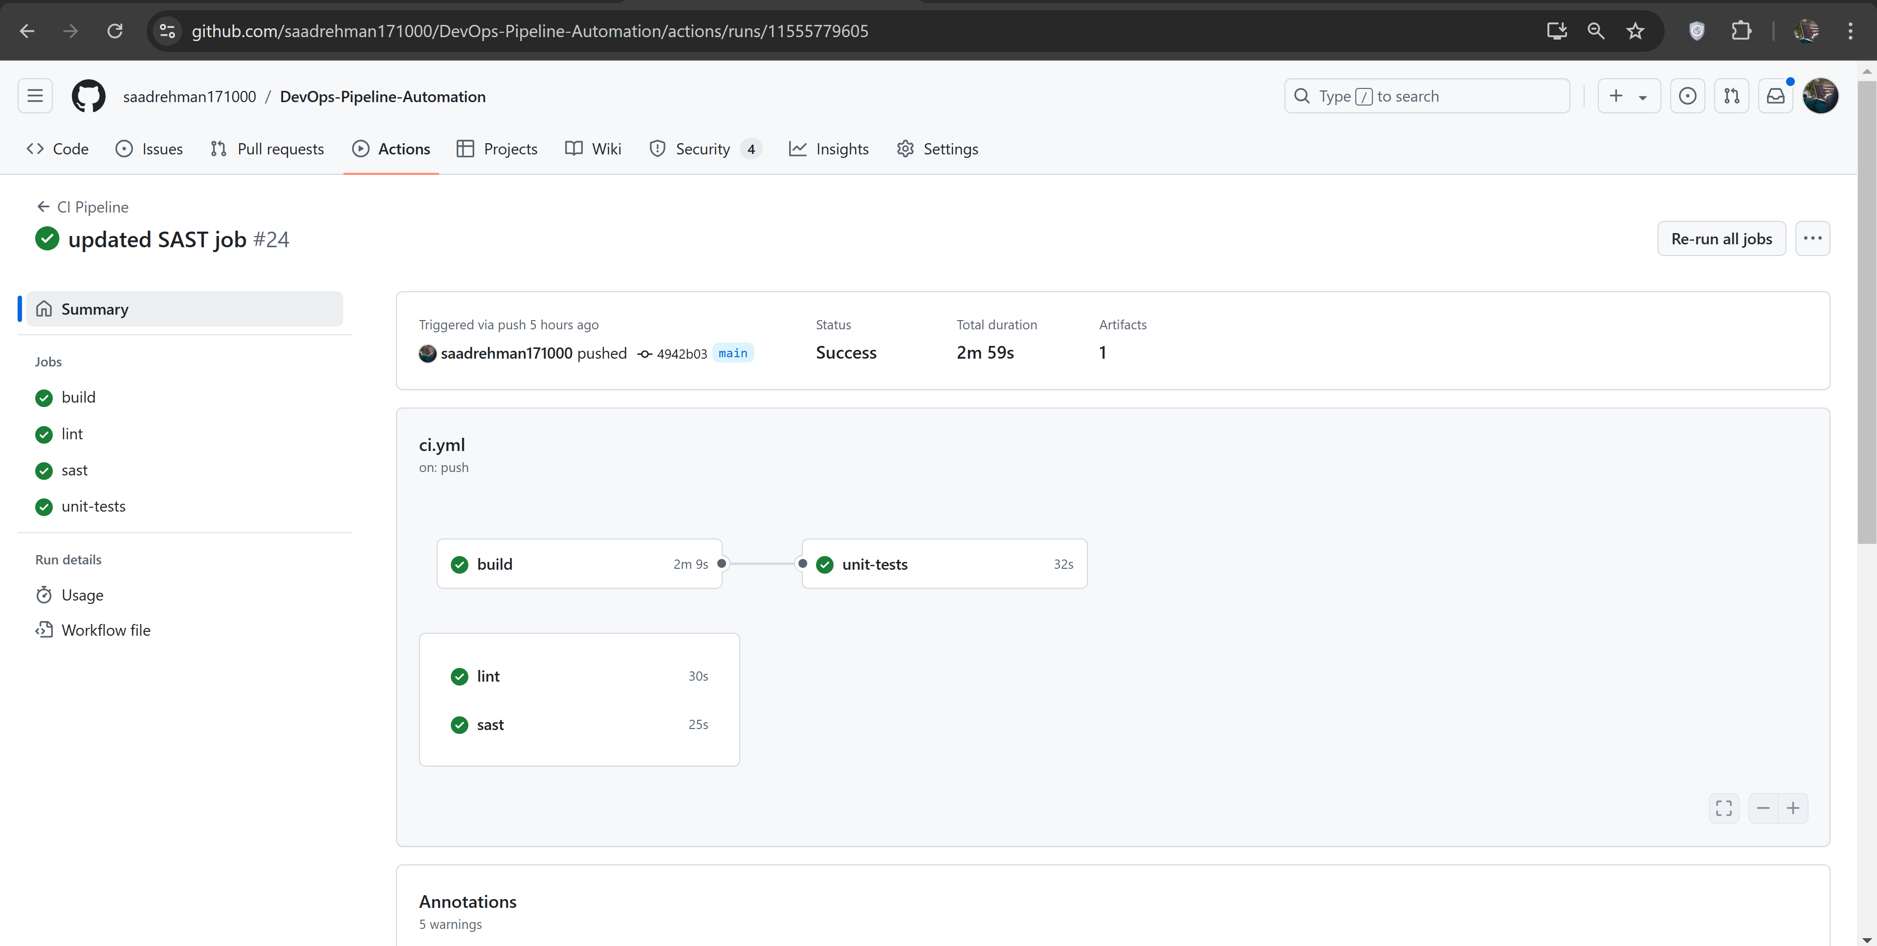

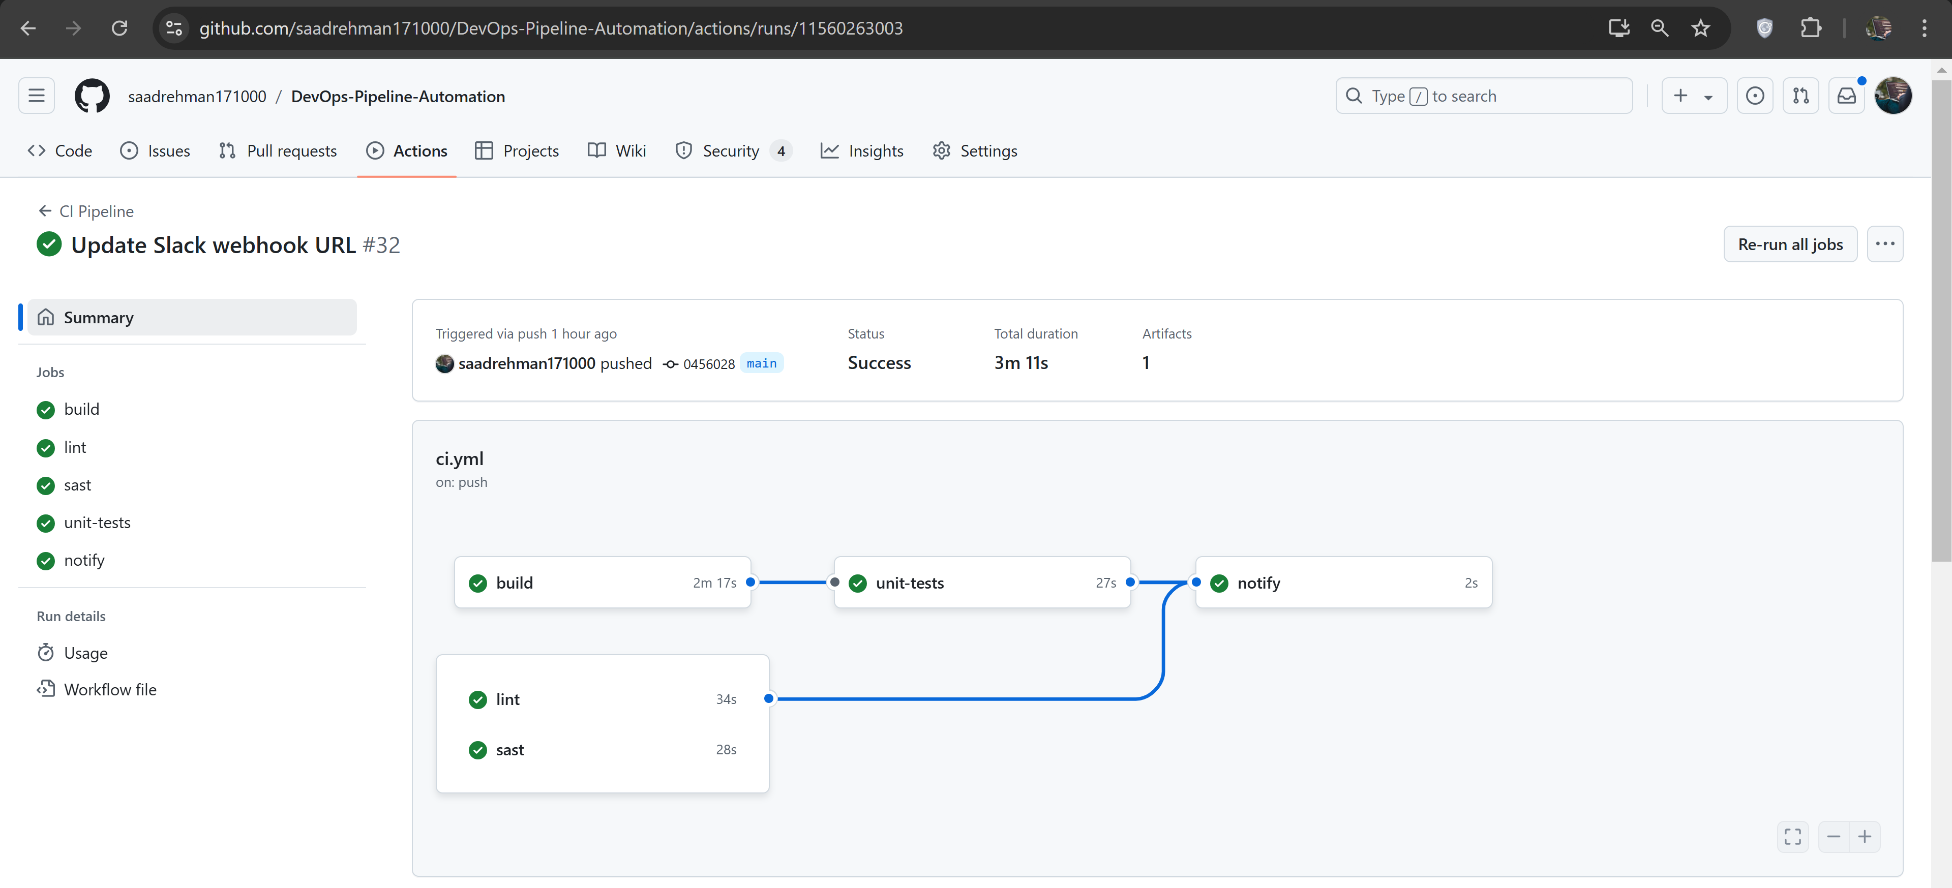

## **4.2 Pull Requests:**

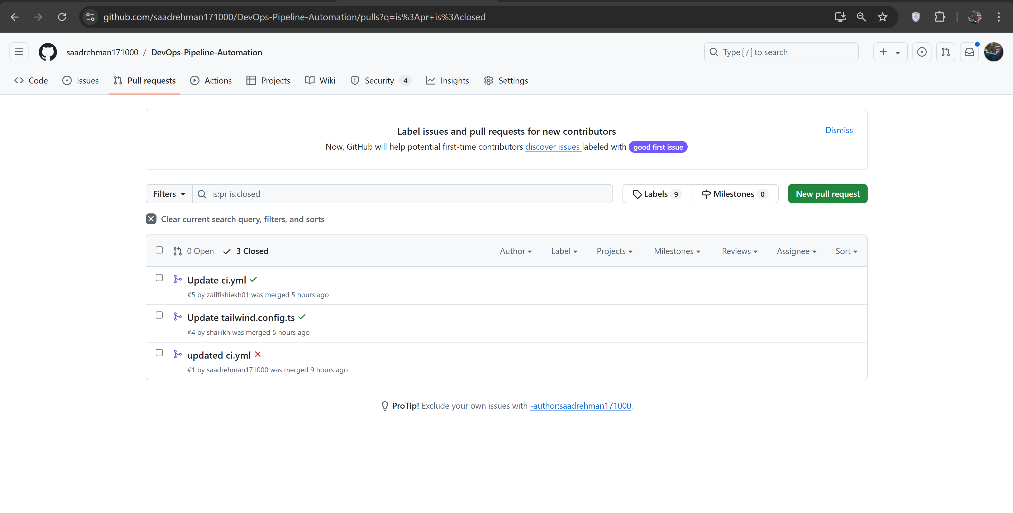

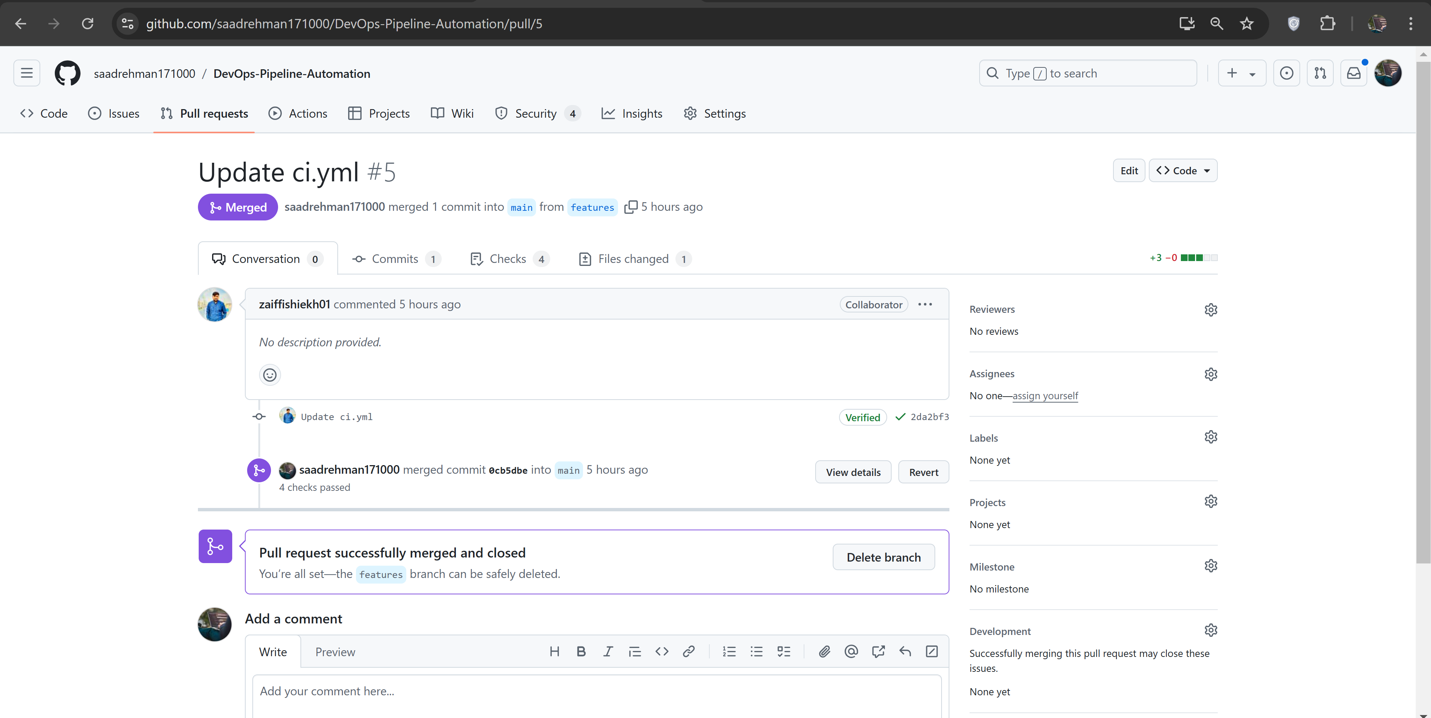

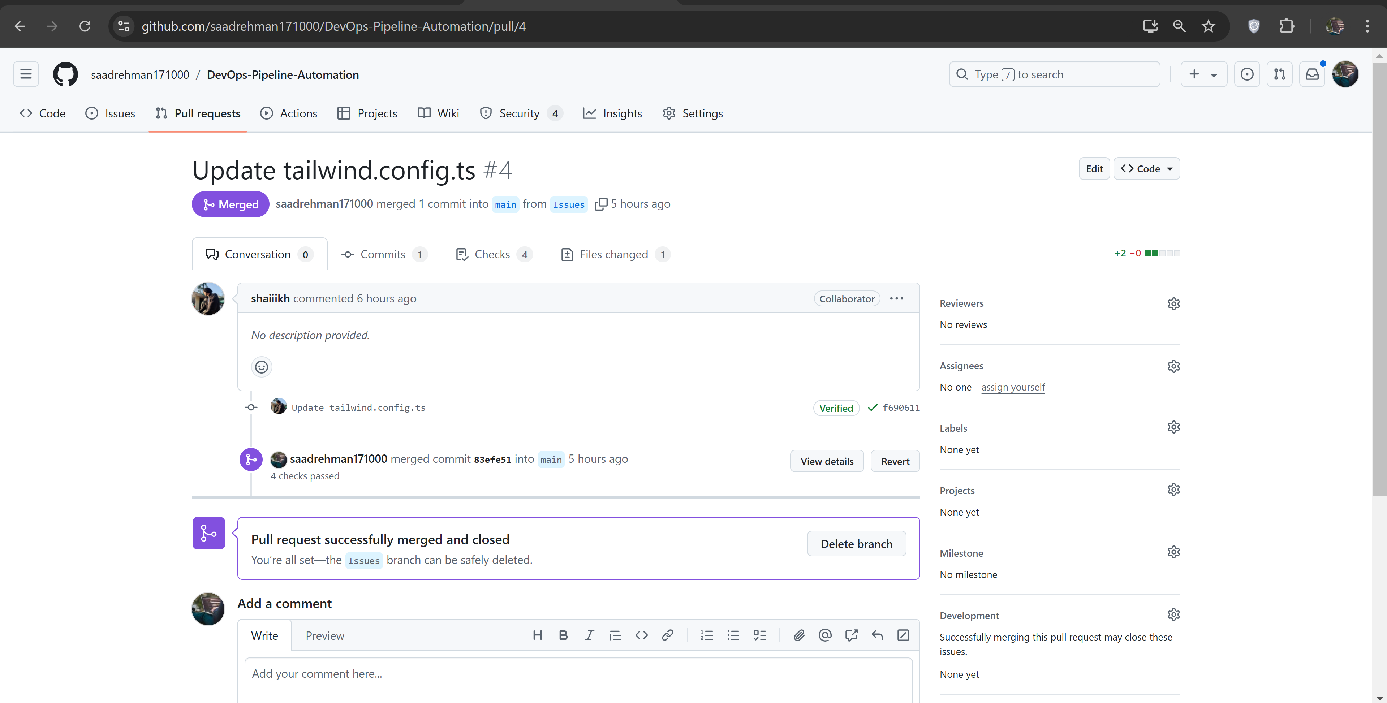

## **4.3 Issues Tracking:**

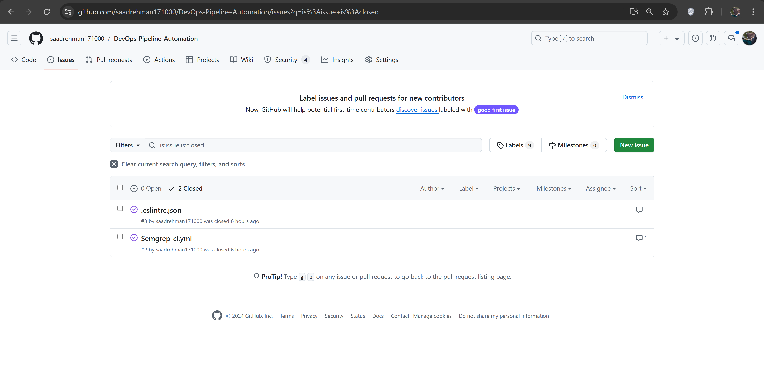

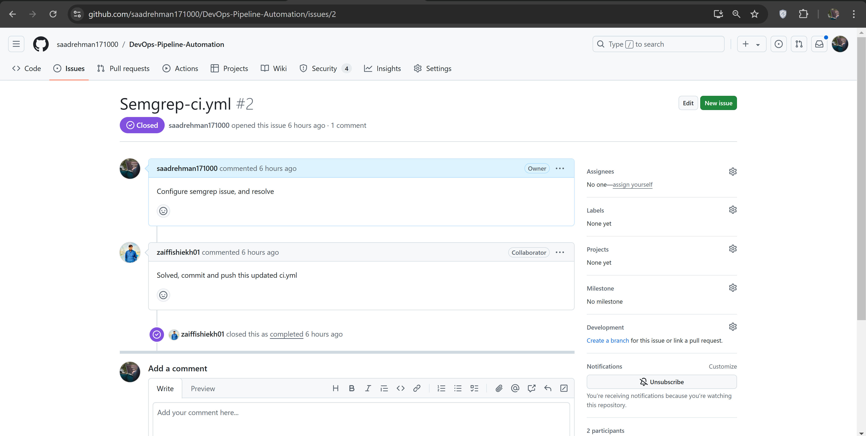

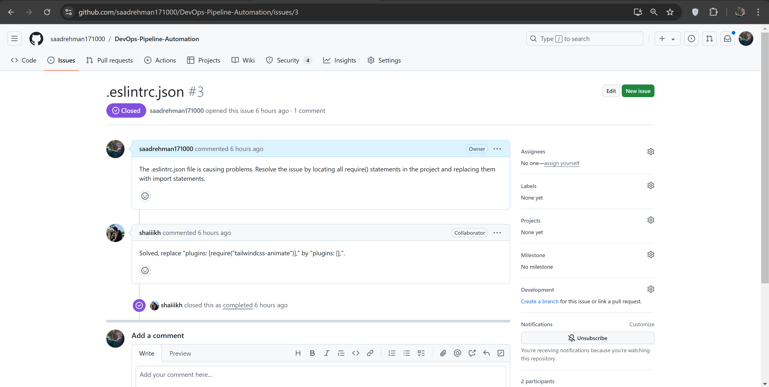

# **5. Monitoring with Slack Incoming Webhook**

To implement monitoring for the CI pipeline, an incoming webhook was created in Slack, allowing notifications to be sent to a designated channel. This setup helps track the status of CI jobs and provides immediate feedback on job execution.

## **5.1 Creating the Slack Incoming Webhook**

1. **Accessing Slack API**: The process started by navigating to the Slack API website and selecting the appropriate workspace.
2. **Creating a New App**: A new app was created within the Slack workspace, followed by configuring the app settings.
3. **Adding Incoming Webhook**: The incoming webhook feature was enabled, which provided a unique webhook URL. This URL is crucial for sending messages to the designated Slack channel.

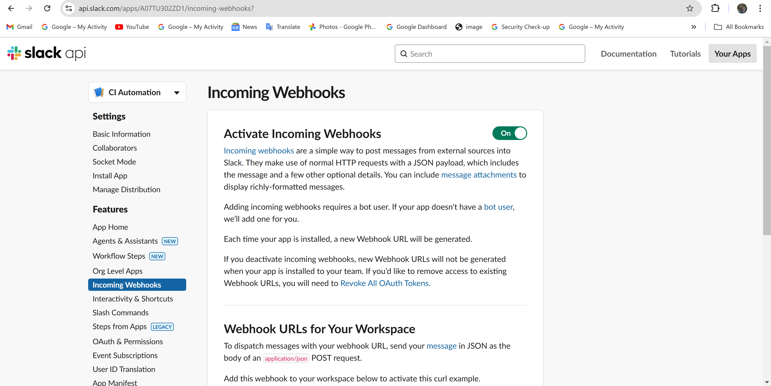

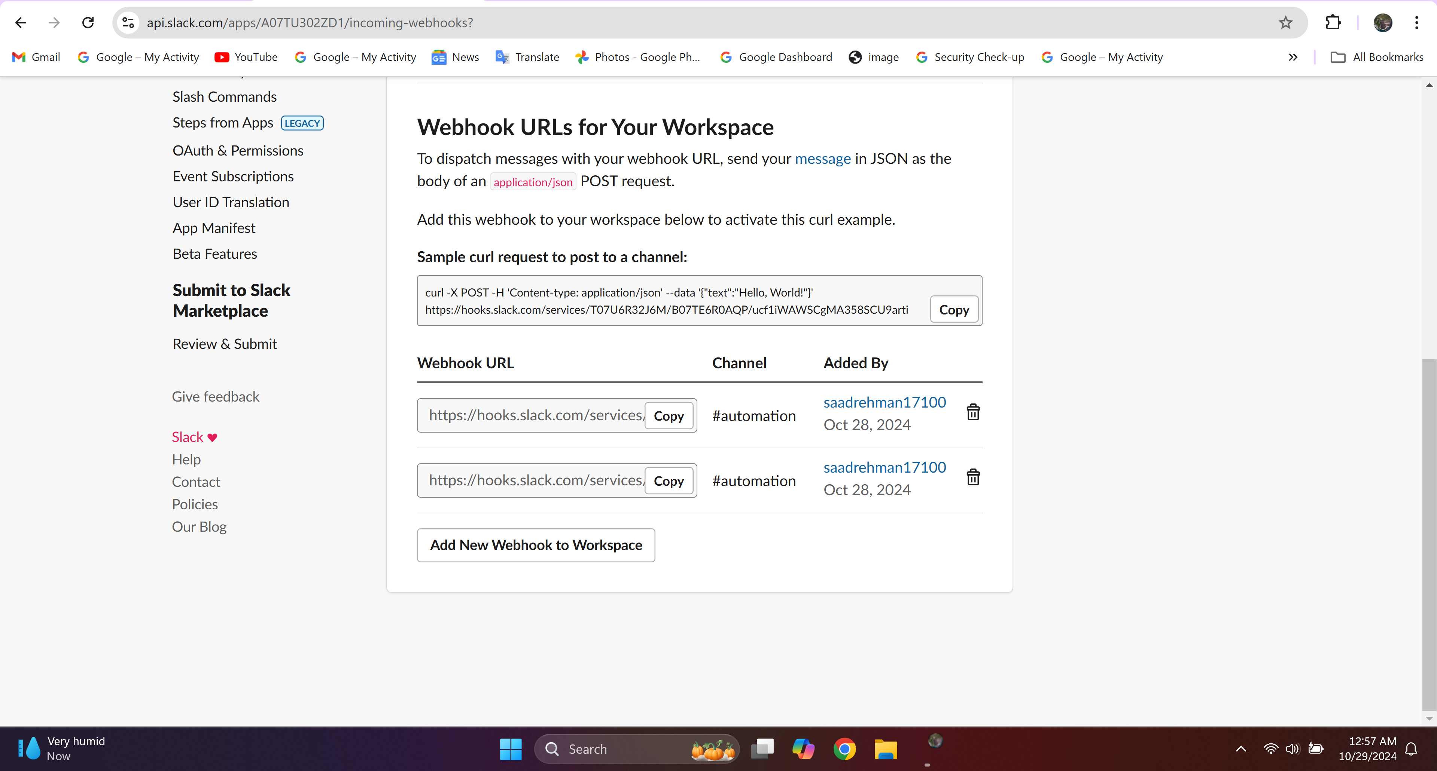

## **5.2 Updating GitHub Secrets**

1. **Navigating to Repository Settings**: The GitHub repository settings were accessed to add the new webhook URL as a secret.
2. **Adding Secret**: Under the "Secrets and variables" section, the webhook URL was pasted into the secret field labeled SLACK_WEBHOOK_URL. This ensures that the webhook URL is secure and not exposed in the code.

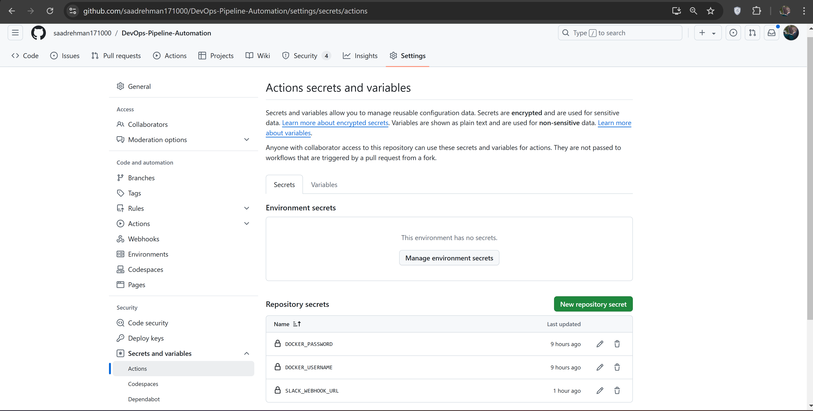

## **5.3 Configuring GitHub Actions for Notifications**

1. **Editing the CI Configuration File**: The CI configuration file (ci.yml) was updated to include a job that sends notifications to Slack upon completion of other jobs in the pipeline.
2. **Adding the Notify Step**: A notify step was defined in the CI configuration to trigger a curl command, which sends a notification to the Slack channel using the incoming webhook URL.

**Command:**

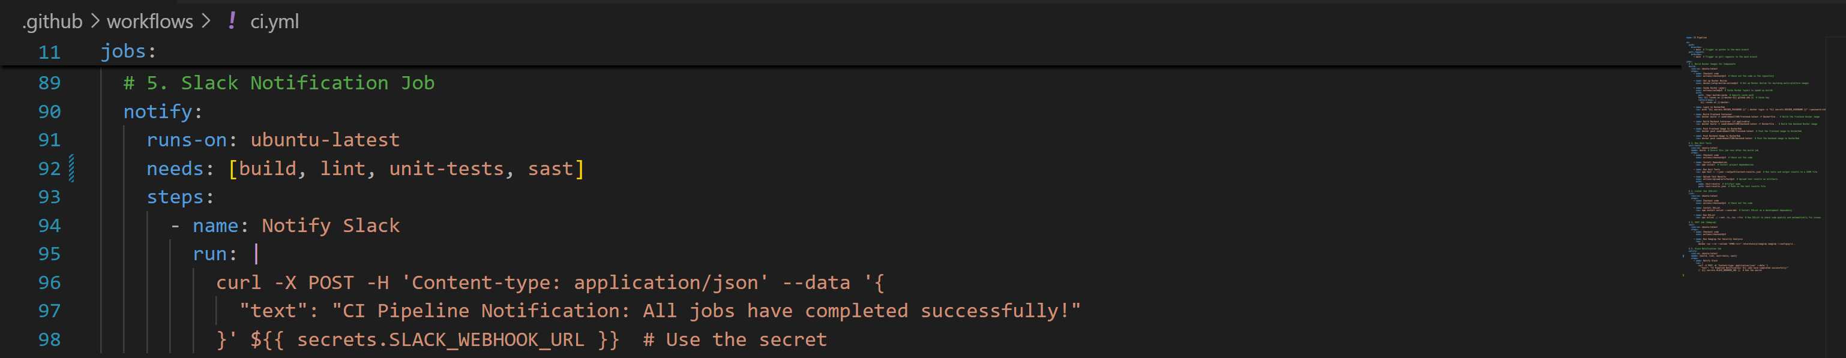

## **5.4 Testing the Notification System**

1. **Triggering CI Pipeline**: After completing the setup, the CI pipeline was triggered by making a commit to the main branch or creating a pull request.
2. **Verifying Notifications in Slack**: Upon successful execution of the CI jobs, a notification was sent to the specified Slack channel, confirming the completion of the jobs.

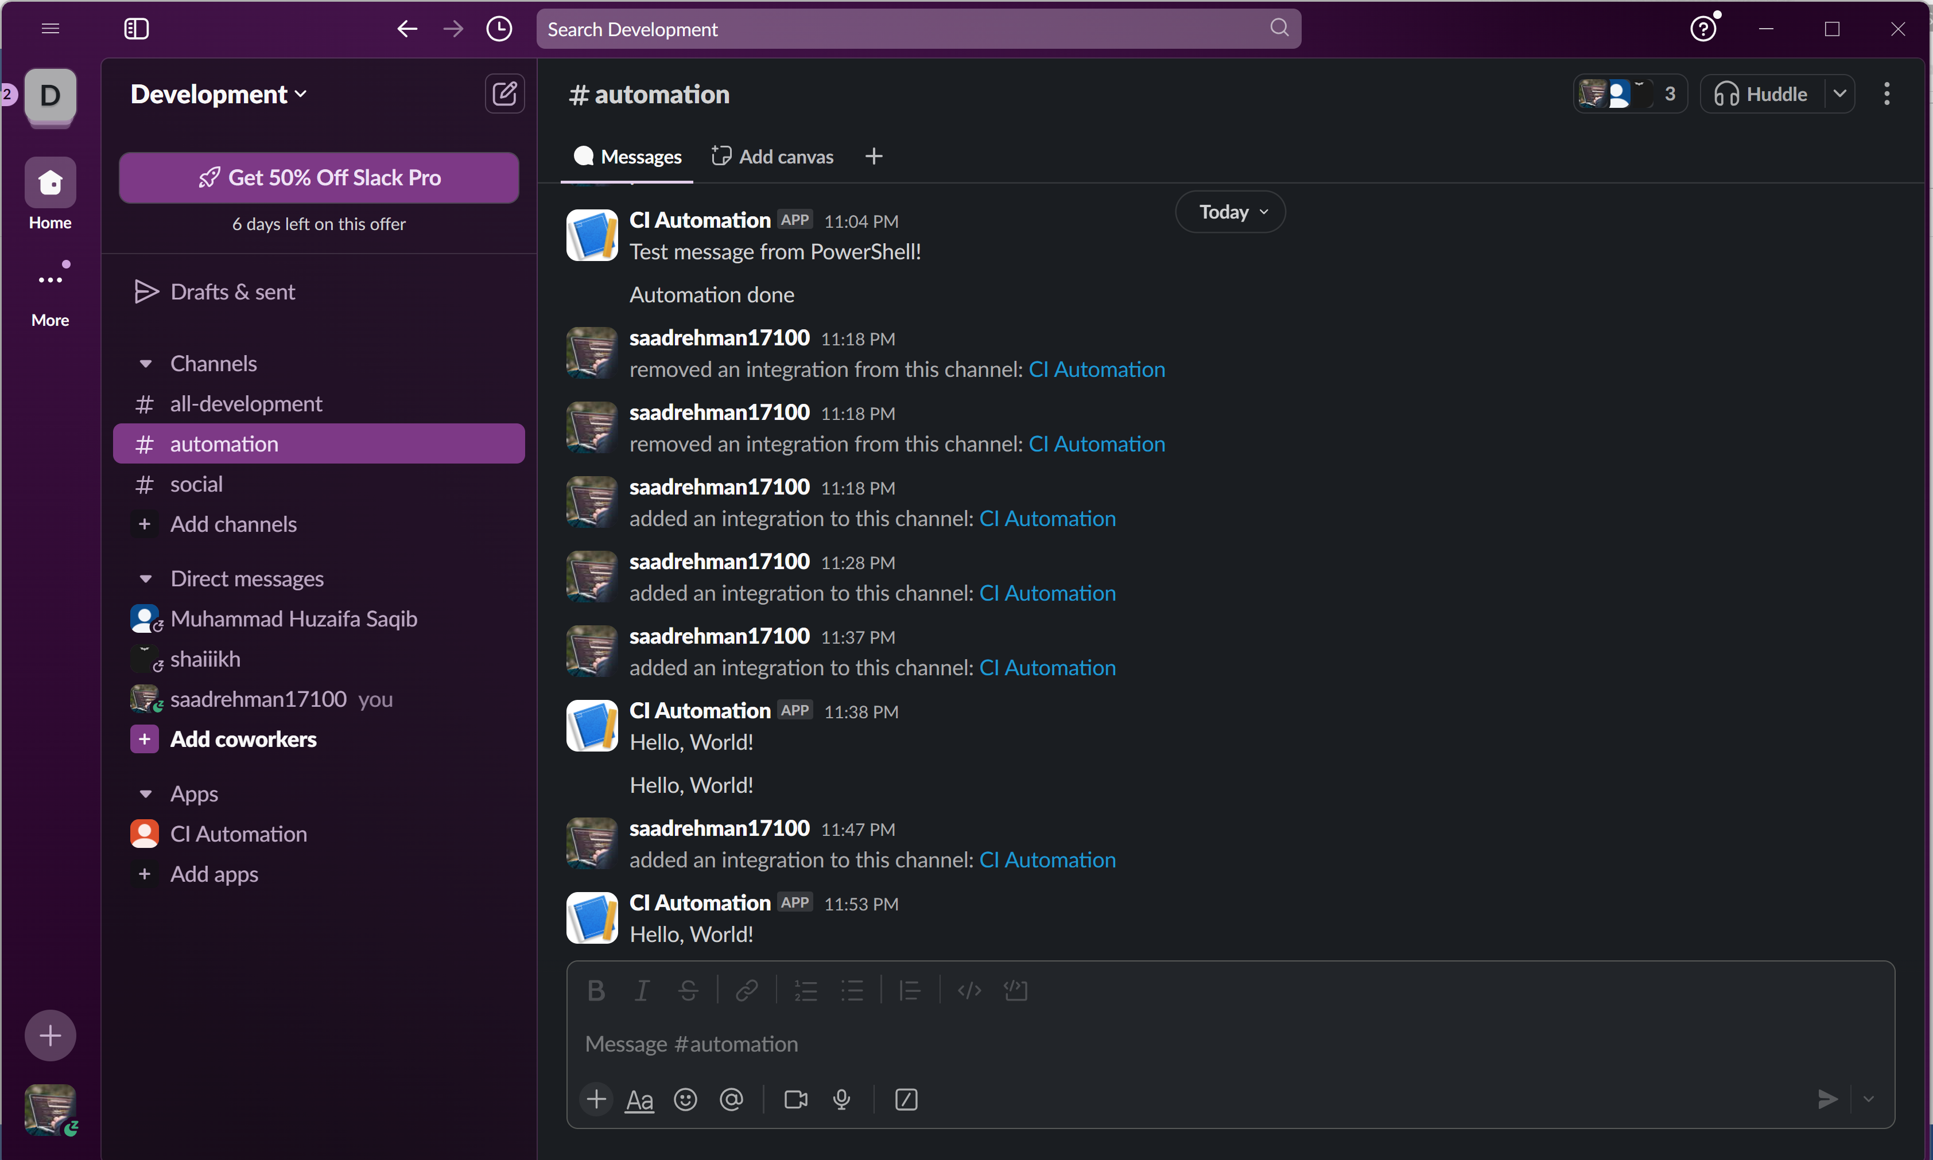

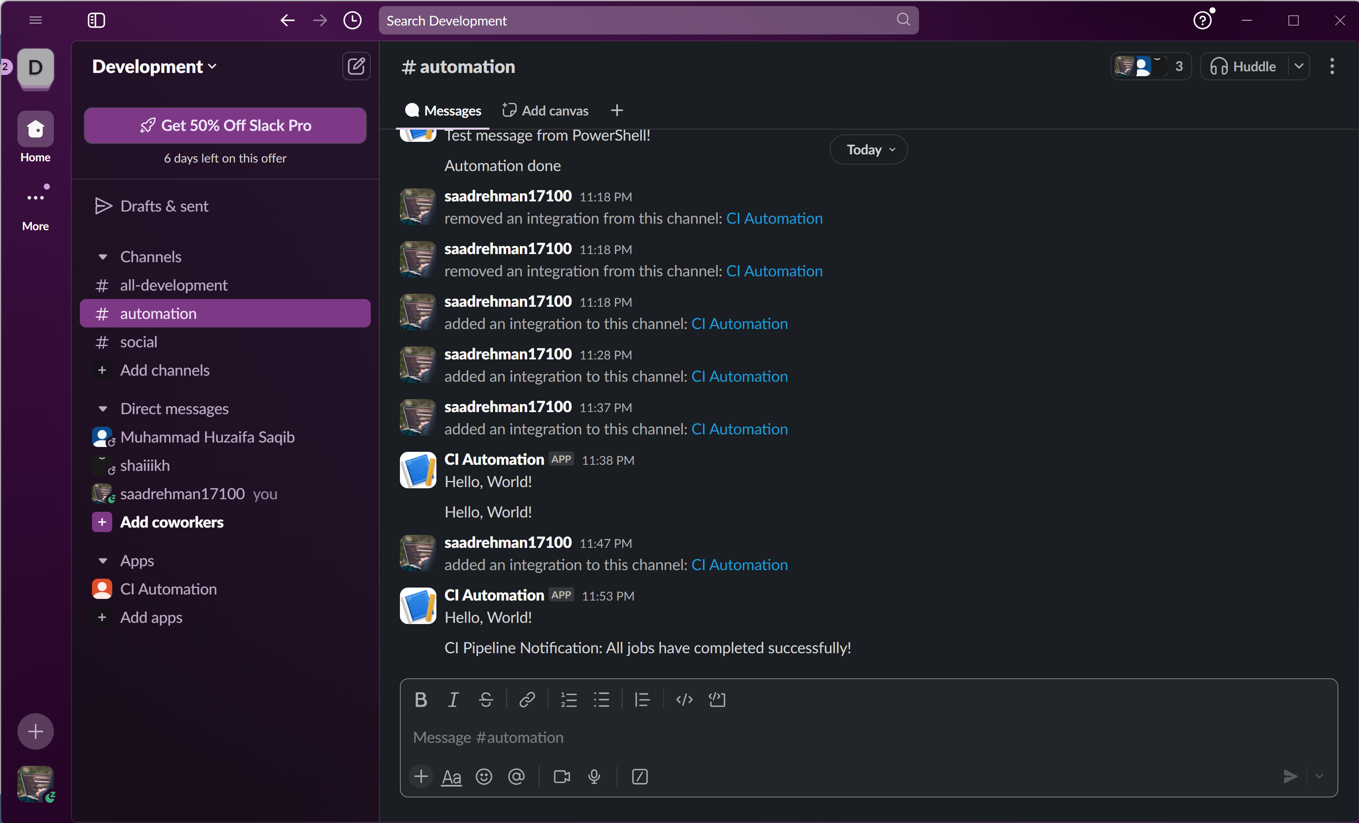

# **6. Conclusion**

The completion of the CI pipeline assignment demonstrated a comprehensive understanding of continuous integration practices using modern tools and technologies. By setting up a robust pipeline utilizing GitHub Actions, Docker, and additional tools like Semgrep for security analysis, the project successfully achieved its objectives.

The following key aspects were effectively addressed throughout the assignment:

1. **Structured Breakdown**: The project was carefully divided into manageable tasks, enabling clear tracking and assignment through GitHub issues. This approach facilitated collaboration among team members and ensured that each aspect of the project was thoroughly covered.
2. **CI Pipeline Implementation**: The CI pipeline was implemented to automate critical tasks, including building Docker containers for frontend and backend components, running unit tests, conducting linting and SAST checks, and pushing images to Docker Hub. Each job was optimized for performance, utilizing caching features and adhering to best practices.
3. **Demonstration of CI Jobs**: Clear documentation of CI job executions, along with detailed histories of GitHub Actions, pull requests, and issues tracking, provided transparency and a comprehensive overview of the development process. This information is vital for assessing the pipeline's efficiency and effectiveness.
4. **Monitoring through Slack Integration**: The integration of Slack incoming webhooks enabled real-time notifications regarding the status of CI jobs. This feature enhances team communication and ensures prompt awareness of job outcomes, thereby fostering a proactive development environment.

Overall, the assignment not only fulfilled the outlined requirements but also provided valuable insights into CI/CD practices, team collaboration, and project management. The skills developed during this project are essential for future endeavors in software development and DevOps, paving the way for continuous improvement in project delivery and team dynamics. The successful implementation of this assignment showcases the ability to integrate modern tools to streamline workflows and enhance productivity within a development team.